Where is the Oversharing Line in Our Adoption Stories?
Question: I just read your article and am an adoptive mom to a beautiful 10 month old boy named Quinton. We have a good relationship with the birth parents and have stayed connected though we reside across the country from them.
We tell almost everyone that Quinton is adopted, often because people exclaim how much he looks like both me and my husband. We feel no shame and only gratitude and pride in and for this beautiful child. But your article gave me pause — is this not my story to tell? Are you saying we should let him reveal that he was adopted to who he wants to rather than us telling them before he’s even ready to understand?
We believe so strongly in the concept of open adoption, that it is better for everyone involved if he grows up without a secret and knowing that we ALL made a loving choice for him to be raised by us.
But I see how this could be seen as me telling his story rather than my own. I mean, it is my story, too, but it certainly isn’t mine alone.
Thoughts?
Amanda
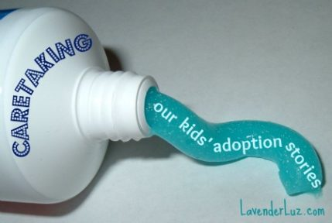

Privacy Rather than Secrecy
I and so many other adoptive parents can so relate to this issue, Amanda. Many proud moms and dads — especially ones who weathered infertility and uncertainty and finally arrived at parenthood — are so relieved to finally have their dream come true that they share excitedly with others HOW the dream came true.
Yours is a common feeling and a natural response.
It’s healthy that you feel no shame in the story of how your family came together, for nothing good comes of shame in adoption. That’s a win for you and Quinton, and that’s why you’re not dealing with a secrecy issue but a privacy issue.
Which means we must be mindful and purposeful with what we share and with whom. Parents find the line between sharing and oversharing when they cultivate a practice of discernment. That’s just a fancy way of saying that you decide what and whom to tell. Each time.

When You Feel the Urge to Squeeze…
It can be difficult when our kids are babies and toddlers, completely dependent on our judgment for everything, to foresee that eventually they will become their own person. And this person will have his own ideas and preferences about who knows his story, how and when it’s shared. We can’t possibly know this in the early years.
We are caretakers of the story. And the story is like toothpaste. You know, something that never goes back in the tube.
Whenever you have the urge to squeeze, ask yourself:
- Does this person need to know? The answer to this can be yes for myriad reasons. It could also be no for myriad reasons. The point is to think it through.
- Why are you wanting to tell? Is it to help your child in some way? Or perhaps to feel special yourself? I’m not saying either is “good” or “bad.” The point is, again, to think it through and examine your motivation.
- Might there be any repercussions from telling — not just immediate, but long-term? Take a moment to think it through from your son’s perspective in 5, 10, 15 years.

Avoid the Blurt
These moments of discernment will help you become aware of the razor-thin line between your son’s story and yours, if indeed they can be extricated from each other. This way you make a consciousdecision about telling. The opposite of a conscious decision to tell is an accidental blurt. If it’s any comfort, I know of very few adoptive moms not guilty of this on occasion, especially in the early years.
There’s a spectrum of sharing about adoption stories. Some parents tell no one because of shame (around infertility, for example). Some tell everyone because they haven’t yet developed a filter. In between are decisions you’ll make over time by asking yourself the questions above. Doing so will help you best balance the present and future needs of your child and discover which part of the story is free for you to tell.
I’m presenting a free webinar next month on this topic for the Embryo Adoption Awareness Center. Register here if you’d like to explore this issue further.
Bottom line: Sharing versus oversharing? Take time to discern the difference.

