Welcoming New Family: 5 Ways Grandparents Can Bond with Adopted Grandchildren
National Grandparents Day is held on the first Sunday of September after Labor Day. This holiday celebrates love, caring, and generational growth. No matter how families expand, the connection between grandparents and grandchildren is a special bond.
In cases of adoption, grandparents may worry about difficulties bonding with the adopted grandchild. This is a completely natural concern, but there is no need to worry. Bonds—like families—may form in different ways, but they are always made with love.
Here are five tips for grandparent bonding with newly-adopted children.

1. Don’t Overthink It
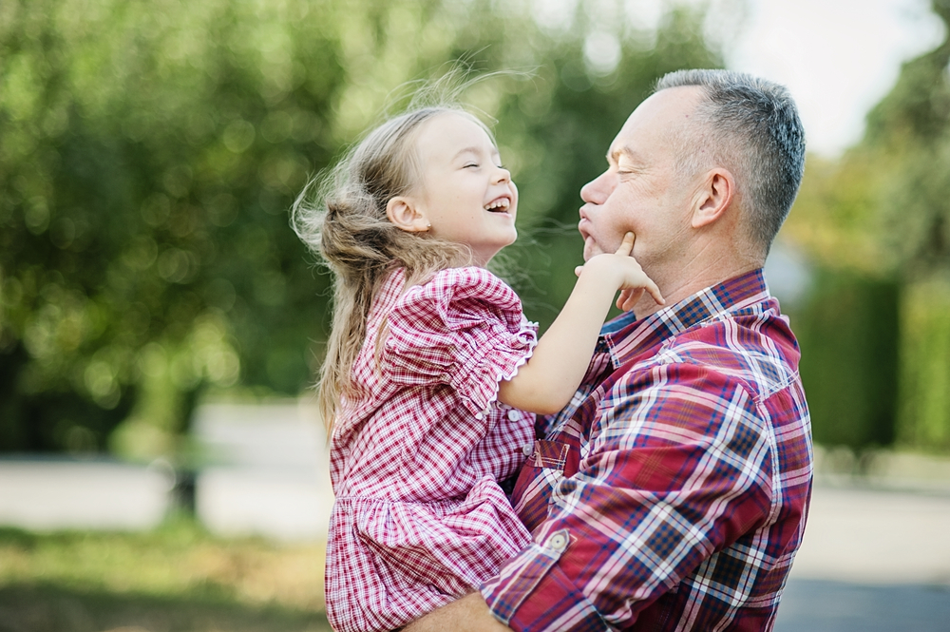
This may be the most important tip. Bonds between grandparents and grandkids form naturally. Putting undue pressure on yourself to sense a connection will not help your concerns. Instead, meet your newly-adopted grandchild openly and honestly. Your bond will form over time; there is no need to rush.

2. Connect with Parents

Your own child is a great point-of-contact for all sorts of great information about your newly-adopted grandchild! Check-in, ask questions, respect boundaries, and offer support—grow together as a family!

3. Scrapbooking
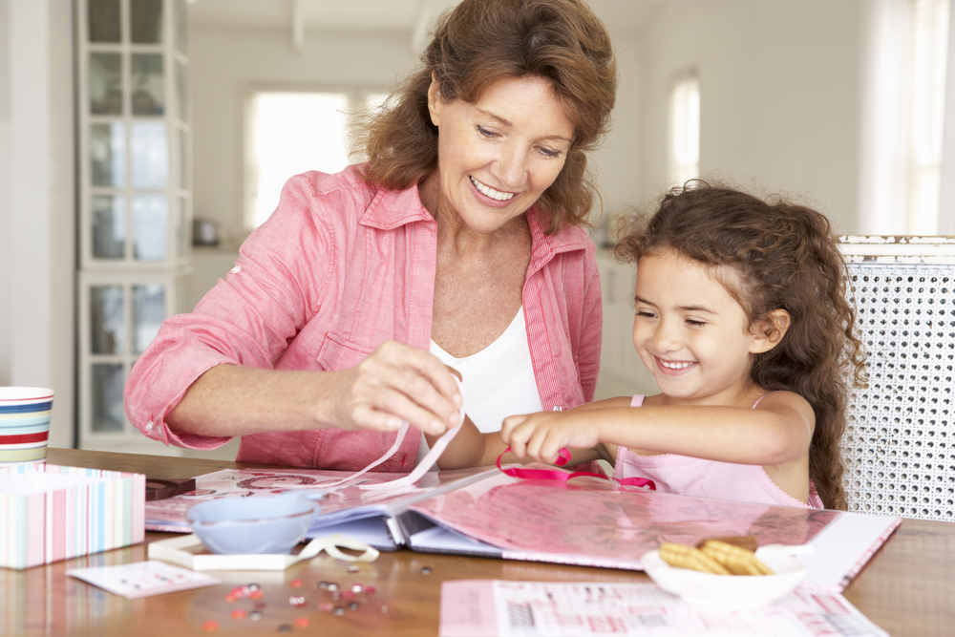
If you are looking for a bonding activity to share with your newly-adopted grandchild, scrapbooking is a wonderful choice. When the child is old enough, sit down with a box of old family photos, and ask for help arranging them and decorating a scrapbook. Creative activities really let personalities shine, and you can share family stories to go along with the photos. As an added bonus, you can engage with your grandchild and learn where they feel they fit in your family fabric.

4. Involve Them in Tradition
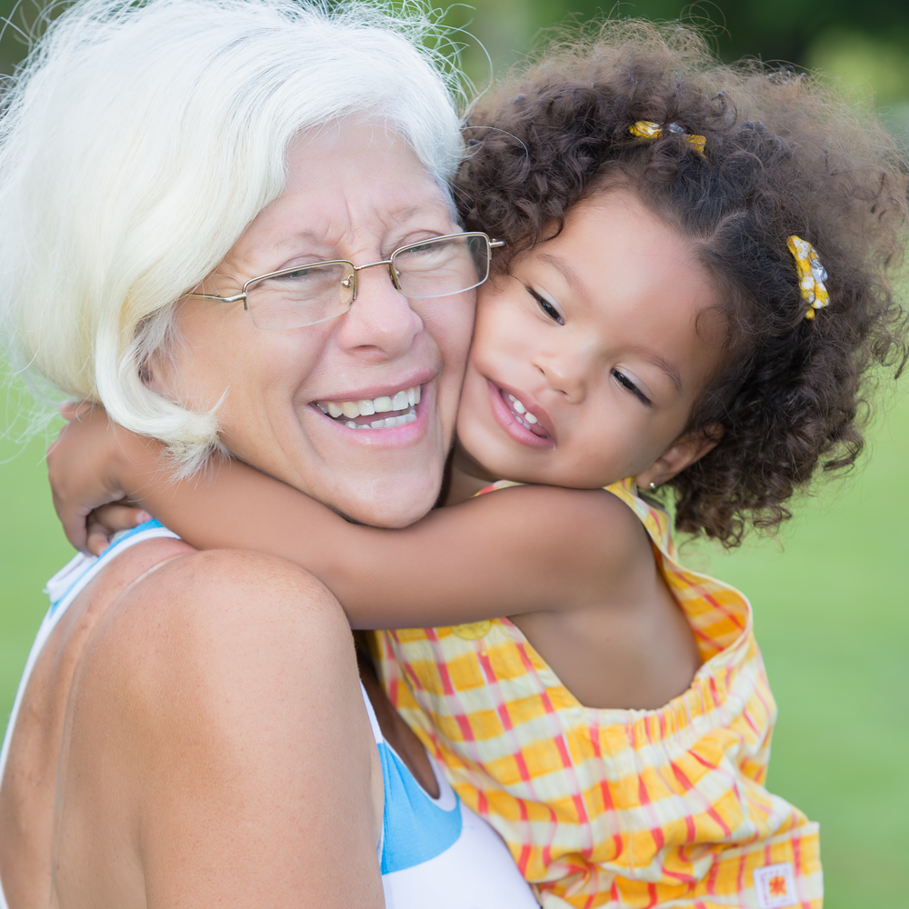
This may come naturally, but it is important to make sure the adopted-grandchild feels included in family traditions. Fill them in on your family history and inside jokes; let them be a part of new tradition development as you celebrate the happiness they bring to your family.

5. Stay in Touch

Feeling that new bond may be difficult if you do not live near your newly-adopted grandchild. Skype and other video conferencing platforms have brought phone calls to a new level of connectivity; these tools are excellent options for distance communication. However, if you are not tech-savvy, or if you want to start a new tradition—consider writing letters to your newly-adopted grandchild. Yes—pen-and-paper letters! This may be the digital age, but that only makes the novelty of postal mail more exciting. Younger kids, especially, will be thrilled to receive real mail! You can send notes, cards, cookies, and more! You can even encourage your grandchild to write back by including a self-addressed, stamped envelope in with your letter.
Grandchildren are blessings, and your heart will recognize them as such. Adoption is just another form of the miracle of families.
& Missouri Only
16236 Metcalf Avenue

