WHY SOME ADOPTED KIDS REJECT MOM
BY PAULA FREEMAN
- SEPTEMBER 27, 2018
Share on facebook
Share on twitter
Share on pinterest
Share on print
Share on email
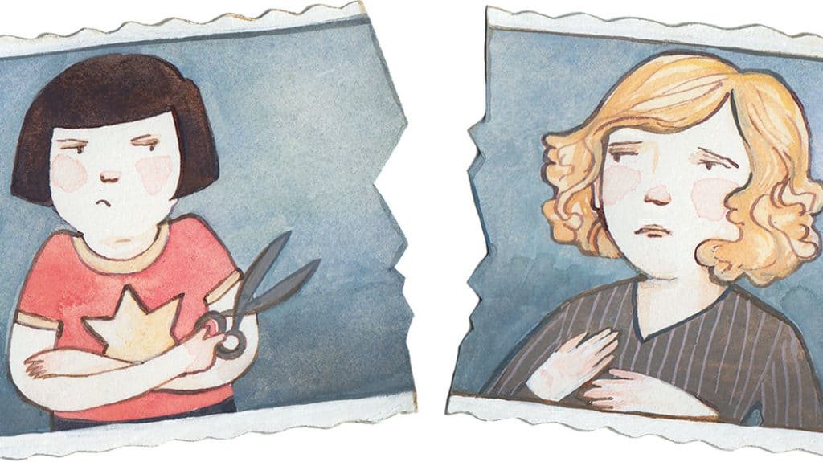Kelsey Garrity-Riley
If you feel rejected as an adoptive parent, you are not alone. Understanding why some children reject Mom can help lead to healing.
“I hate you, and I want to hurt you!” my daughter screamed. “I wish you had never adopted me!”
Responses such as these left me feeling deeply rejected. Later I learned I wasn’t the only adoptive mom who has felt this way.
When the bond between a child and biological mother is broken, some children try to protect their hearts from further trauma; they resolve to never have another mom. They still need a cook and chauffeur, but fear emotional intimacy. The thought of losing another mother is simply too much to bear. Thus Mom becomes the target of her child’s rejection because she’s the greatest emotional threat.
Countless adoptive parents experience this, yet there is hope! Consider these ideas:
Reframe your view. Understanding the cause of an adoptive child’s rejection helps unite the parents and prevent them from misinterpreting and punishing a child’s behaviors. It also releases women from the shame and blame they feel for not being a “good-enough” mom.
Responding in a matter-of-fact way to rejection can help reduce a child’s fear of intimacy. Ask God to give you compassion for your child and her need for emotional protection. Your child needs and wants a mom, even when she doesn’t act as though she does. I learned to calmly affirm my love for my daughter and offer her a chance to redo her behavior.
Seek professional help. Godly counsel from a professional with experience in adoption issues can help reveal the complex emotions that often sabotage healthy parenting. Unaware that my daughter’s rejection reopened emotional wounds from my past, I over-reacted to her behavior and then felt consumed by guilt and depression. Counseling helped me stop blaming myself for my daughter’s behavior and respond to her in a way that was healthy for both of us.
Be gracious. Dads, understand your wife’s vulnerable position and graciously support her. Believe her when she says your child behaves differently with you. And moms, be as gracious to yourself as God is toward you. Rely on the Lord to keep your soul at peace, even in the face of your child’s rejection.
This article appeared in the March/April 2014 issue of Thriving Family magazine and was titled “Why Don’t You Love Me Back?” © 2014 by Paula Freeman. Used by permission.

