Safety in Numbers

An adoption support group can be an excellent resource. Here's how to find the right one for your family.
by Carrie Howard
TAGS: Adoption Resources, Single Parenting, Support Groups & Community, Transracial Adoption
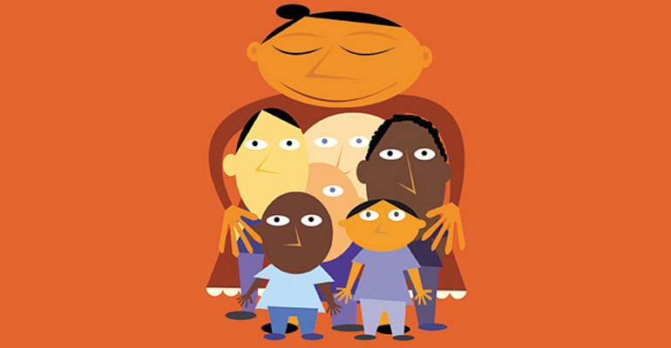
One of the happy surprises of adoptive parenting is the friendship and camaraderie to be found in adoption support groups.
While friends and family don’t always understand the joys and challenges of raising children whose ethnicity, special needs, or personal histories may set them apart, support groups can provide information, companionship, and enrichment that you won’t find elsewhere.
There are groups for families adopting domestically and internationally, for waiting parents, families with toddlers, and teenage adoptees. Veteran adoptive parents know there’s an art to finding a group where they — and their children — feel at home.

A Lid for Every Pot
Sandee McAlpine belongs to a support group for families who have adopted children from Korea. She has found the focus of the group helpful, and the group has adapted well to her family’s needs over the years.
“It really helped me in those early days, when I was dealing with issues like those rude questions people ask,” she says. “Now that our son is seven, the best parts are the cultural events and the friends my son has who look like him and come from families that look like his: Caucasian parents and Asian kids.”
Cheri is the adoptive mother of three children who have special needs. Her oldest daughter, now 20, was adopted at age eight from Vietnam, and her younger children are African-American twins, now 13, who were adopted at age four.
“When my older daughter was quite young, I was a member of a group for parents of children born internationally,” says Cheri, “but there was too much age variation among the children. Most parents were interested in potty training when I was concerned about my daughter’s attachment problems.”
Cheri found better support when she joined groups relating to the specific needs of her children. “These groups were not limited to families of adoptive children,” she explains, “but I think my children gained a lot from them. They realized there were other children who struggled with day-to-day issues, just as they did.”
For single parents, a support group can be especially helpful. Rita Cheresnowsky is the single mother of a three-year-old adopted from Guatemala. She belongs to a Guatemala adoption group and another group that focuses on the needs of single parents.
“While the Guatemala group provides the cultural support I need,” says Rita, “the single adoptive parents group is where people seem to ‘get’ my issues.”
“Although some issues are the same for singles and couples, there are others that a more ‘traditional’ family might not encounter. The joys and exhaustion of parenting as a single really require support. Whether the adoption is international or domestic matters less for me than whether there is one parent or two.”

Virtual Communities
Some parents have found support literally at their fingertips, through online support groups. Wendy Harrison, who is waiting for a referral from China, says of online groups, “I have found these to be the most valuable information around. I have learned about traveling to China, what books to read, how to handle the long wait, and many other great things. I look forward to reading my e-mail every day.”
The downside of large online lists is that they tend to erupt from time to time in heated disagreements or “flame wars.” Harrison feels that she gets more personal support from a smaller group composed of parents who submitted their dossiers to China in the same month she did.
“We have participated in many activities, both on line and off, that have helped us survive the wait for our referrals,” she says.

Changing Needs
Over time, a group that once offered valuable support may no longer provide what a maturing family needs. Patty and Dan Paolini enjoyed participating for several years in a group for families with children from China. But as the children grew older, the family found the group too infant-oriented.
So they switched to a general adoption support group, with participants of all ages. “We didn’t want our children growing up thinking that all adopted children were from China,” Paolini says. “When our new group went roller skating and I told our son that most of the children there were adopted, he didn’t believe me.”

Breaking Up Is Hard to Do
Gerry De Meo has two daughters, Katy, eight, and Jessica, seven, who were adopted domestically. The first support group she joined didn’t work out. “About 10 families met off and on for about a year and a half,” she says.
“We were the only family who adopted through a public agency. After a while we just stopped meeting. I think part of the problem was that we all came from different economic and social backgrounds. The fact that we had adopted children wasn’t enough to hold the group together.”
De Meo has since found a group that better suits her. “I joined an adoption support group through the county,” she says. “We meet twice a month, and the county provides a meal and daycare for our children. All of our children had the same pre-placement experiences.”
“I live for these meetings. This is a group of women — and sometimes a father or two — to whom I can really relate. We have the same problems, desires, and concerns for our children. We have supported each other outside the group, and we socialize together.”

Striking a Balance
Kathie Stocker, a social worker who works with adoption support groups in Oregon, says, “I don’t see any problem with being in more than one group. You can get tunnel vision by being in a group that deals only with ethnicity and doesn’t address adoption issues, for example.”
Stocker, who has two children, one of whom was adopted from Korea, says, “I can see the pluses of both general groups and specialized groups. When my daughter was little, the diverse group was great. Now that she’s a teenager, she needs to be with other Korean teenagers. She appreciates that they have similar issues — what they look like, who they date, why they’re not represented in the media, and so on.”
The beauty of adoption these days is that you can learn from others who’ve been there before you. “It’s hard to do adoption alone,” says Kathie Stocker, “what with the waiting and uncertainty and lifetime of unanswered questions. I encourage families to find support — and to do it when they’re first starting out.”

Support Group Resources
To find a local group, consult:
- Adoption agencies, state and county social service agencies, and therapists specializing in adoption and family issues may conduct support groups or offer other referrals.
- The Family Helper web site lists adoption support groups in Canada, sorted by province: groups.yahoo.com.

