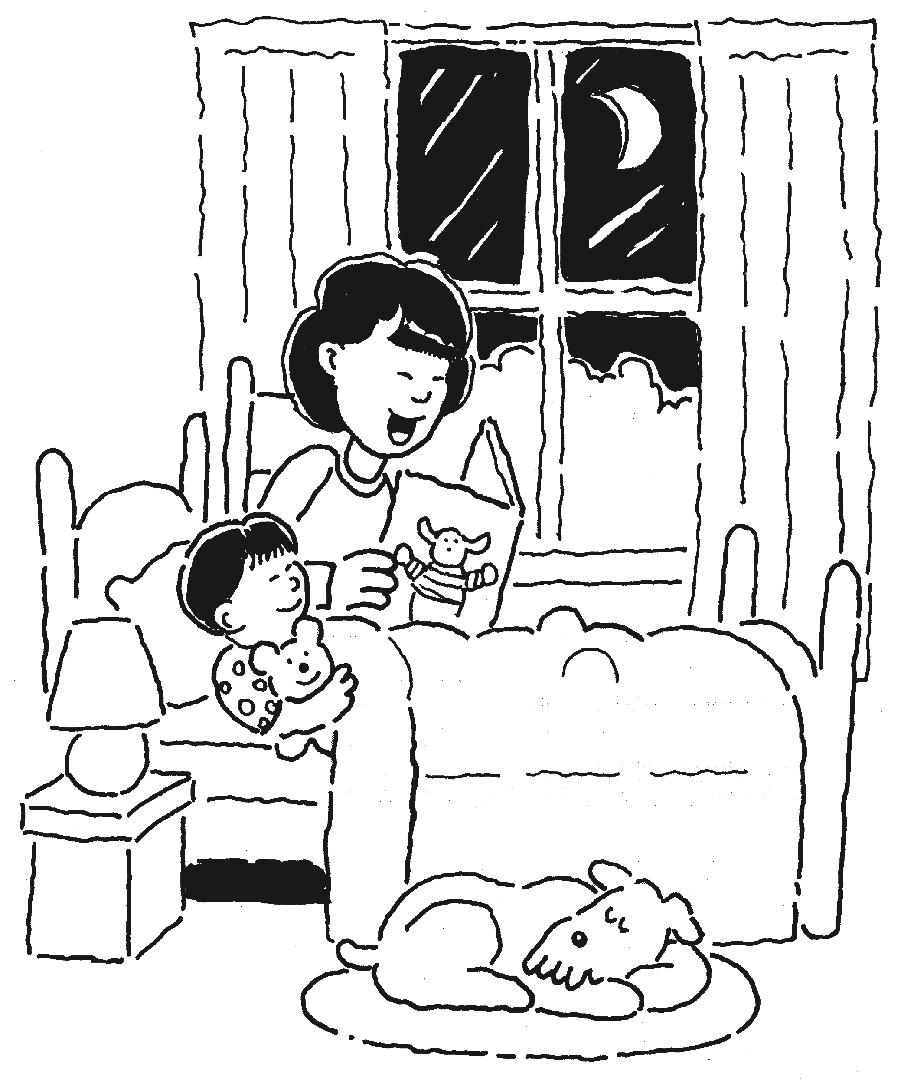
Home Safety Checklist
Is your house a safe place for your child to live and play? The following safety checklist can help you prevent serious injuries or even death. Though it addresses common safety concerns, it’s important to remember that every house is different and no checklist is complete. Because there may be
other safety concerns in your house, a more thorough safety check is recommended at least every 6 months.
Your child’s bedroom Changing table
- Never leave your child unattended. Keep supplies within arm’s reach and
always use the safety belt to help prevent falls. Try to keep a hand on your
child at all times, even when using the safety belt.
- Make sure drapery and blind cords are out of reach. Loose cords can
strangle children. Keep the cords tied up high with no loops. Check the
cords in other rooms as well.
- If you use baby powder, pour it out carefully and keep the powder away
from baby’s face. Published reports indicate that talc or cornstarch in baby powder can injure a baby’s lungs.
Crib
- Lower the risk of sudden infant death syndrome (SIDS). All healthy babies younger than 1 year should sleep on their backs—at nap time and at night. The safest place to sleep is in a crib with a firm mattress with a fitted sheet. Keep pillows, quilts, comforters, sheepskins, and stuffed toys out
of your baby’s crib. They can cover your baby’s face—even if she is lying on her back. Also, bulky items left in the crib could be used as a step for climbing out when your baby is able to stand.
- Don’t hang anything with strings or ribbon over cribs.
- Make sure the crib has no raised corner posts or cutouts. Loose clothing
can get snagged on these and strangle your baby. Also, the slats on the crib should be no more than 23⁄8 inches apart. Widely spaced slats can trap small heads.
- Use a mattress that fits snugly in the crib so your baby cannot slip in between the sides of the crib.
- Tighten all the screws, bolts, and other hardware securely to prevent the crib from collapsing.
Other bedroom items
- Night-light. Keep night-lights away from drapes or bedding where they could start a fire. Buy only cool night-lights that do not get hot.
- Smoke alarms. Install smoke alarms outside every bedroom (or any
area where someone sleeps), in furnace areas, and on every level of your home, including the basement. Buy alarms with long-life lithium batteries. Standard batteries should be changed every year. Test alarms every month to make sure they are working properly.
• Window guards. Make sure window guards are secured to prevent a child from falling out the window.
• Outlets. Use plug protectors in all outlets in your home. Children can be burned or shocked from sticking their fingers or other objects into the holes.
• Toy chest. The best toy chest is a box or basket without a lid. However, if it has a lid, make sure it has safe hinges that hold the lid open and do not pinch. The chest should also have air holes just in case your child gets trapped inside.
• Humidifier. Use a cool-mist humidifier to avoid burns. Clean it often to avoid bacteria and mold growth.
The kitchen
- Store sharp knives or other sharp utensils and dishwasher detergent and other cleaning supplies in a cabinet with child locks.
- Keep chairs and stools away from counters and the stove where a child could climb up and get hurt.
- Use the back burners and point pot handles toward the back of the stove to keep them out of your child’s reach. Keep your child away from the stove when someone is cooking.
- Keep electrical appliances out of your child’s reach and unplugged when not in use. Appliance cords should be tucked away so they cannot be reached by a child.
- Use a high chair that is sturdy and has a seat belt with a crotch strap.
- Keep a working fire extinguisher in the kitchen and know how and when to
use it.
The bathroom
• Always stay within arm’s reach of your infant or young child when he is
in the bathtub. Many bathtub drownings happen (even in a few inches of water) when a parent leaves an infant or young child alone or with another young child.
• Keep the bathroom door closed when not in use. Keep the toilet seat cover down and consider using a toilet lid latch. Use a doorknob cover to keep your child out of the bathroom when you are not there.
• Use a nonskid bath mat in the bathtub and on the floor.
• Keep all medicines, toiletries, cosmetics, and cleaning supplies out of your child’s reach. Store these items in cabinets with child locks. Make sure all
medicines have child-resistant caps on them.
• Unplug and store hair dryers, curling irons, and other electrical appliances
out of your child’s reach.
• Make sure the outlets in the bathroom have ground fault interrupters
(GFIs).
• The hottest temperature at the faucet should be no more than 120°F to
avoid burns. In many cases you can adjust your hot water heater.
The family room
- Pad edges and corners of tables.
- Keep houseplants out of your child’s reach because some may be
poisonous.
- Make sure TVs and other heavy items (such as lamps) are secure so they
don’t tip over.
- Check electrical cords. Replace any cords that are worn, frayed, or
damaged. Never overload outlets. Cords should run behind furniture and
not hang down for children to pull on them. Remove unused cords.
- Place a barrier around the fireplace or other heat sources.
- Store matches and lighters out of your child’s reach or in a cabinet with
child locks. Teach your child that matches and lighters are to be used by adults only.
Throughout the home
Take a look throughout your home and check for the following:
- A home is safest without firearms. If you must have a gun, make sure the gun is stored unloaded and locked in a safe or with a trigger lock, and bullets are locked in another place.
- Block all stairs with gates.
- Make sure all the rooms in your home are free from small parts, plastic
bags, small toys, coins, and balloons that your child could choke on.
Frequently check in, around, and under furniture.
- Make sure to have a plan of escape from your home in case of a fire.
Review and practice the plan with your family.
- Post the poison help line number (1-800-222-1222) on all your phones.
- Teach your child how to call 911 in an emergency.
- Only use candles when an adult is in the room. Blow out candles if you
leave the room or go to sleep.
- Teach your child to never pick and eat anything from an indoor or outdoor
plant.
The playground
- Make sure swings are made of soft materials, such as rubber, plastic, or canvas.
- Use wood chips, mulch, or shredded rubber under play equipment. It should be at least 9 inches deep for play equipment up to 7 feet high. Frequently rake the material back under the swings and slides to keep it the right depth.
- Make sure home playground equipment is put together correctly, sits on a level surface, and is anchored firmly to the ground.
The pool
• Make sure to have a 4-foot fence around all sides of the pool to separate the pool from the house. A child should not be able to climb the fence. The gate should open outward and self-close and self-latch with the latch high out of a child’s reach.
• Always have rescue equipment (such as a shepherd hook or life preserver). Keep a telephone by the pool with your local emergency number (usually 911) clearly posted.
Learn basic first aid and cardiopulmonary resuscitation (CPR). Because of the time it might take for help to arrive, your CPR skills can save your child’s life. CPR performed by bystanders has been shown to improve outcomes in drowning victims.
The information contained in this publication should not be used as a substitute for the medical care and advice of your pediatrician. There may be variations in treatment that your pediatrician may recommend based on individual facts and circumstances.
From your doctor

The American Academy of Pediatrics is an organization of 60,000 primary care pediatricians, pediatric medical subspecialists, and pediatric surgical specialists dedicated to the health, safety, and well-being of infants, children, adolescents, and young adults.
American Academy of Pediatrics Copyright © 2008, Updated 12/08 Web site — www.aap.org

