Five Practical Ways You Can Bond With Your Newly Adopted Baby
Rachel Garlinghouse

March 06, 2017
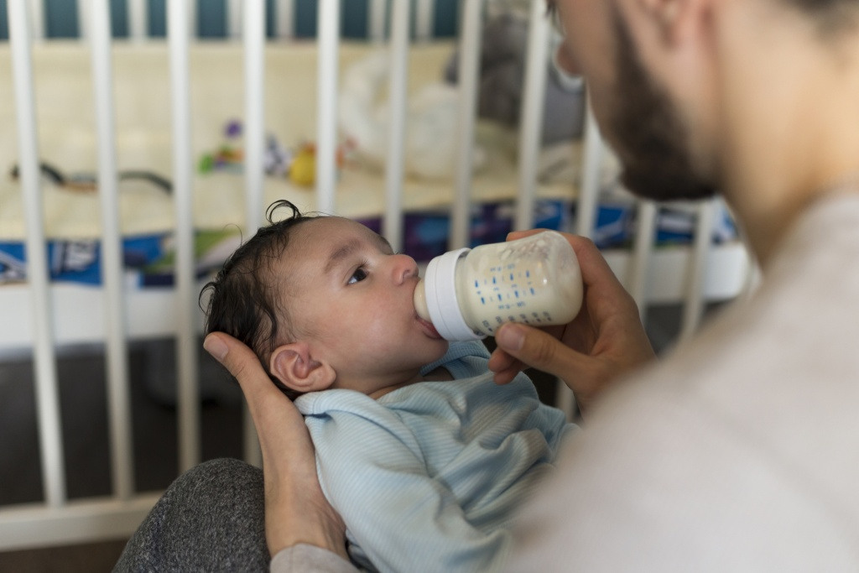
When we adopted our first child, it was a whirlwind experience. We had been waiting fourteen months when we got a phone call saying we had been chosen to adopt a baby girl who was already born. We quickly called an adoption attorney, packed up our car, and drove four hours to our daughter’s birth city.
The minute she was placed in my arms, gazing at me with her inquisitive brown eyes, I felt a swirl of emotions: I was sad for her birth parents, joyful that I was finally a mother, and overwhelmed by the fact that I was responsible for a human life. In the weeks that followed, we took slow, unsteady steps to move from being woman and baby to mother and child.
Many (falsely) believe a newborn baby is a “blank slate” and that bonding should be magical and instantaneous. But the truth is, when you are handed a baby who didn’t grow in your body, bonding can take time. With intention, you can bond with your newly adopted child by considering the following:
1: Baby-Wearing
There are so many benefits to wearing your baby in a proper-fitting carrier. Baby-wearing keeps the baby close to you so he or she can get acclimated to your scent, your heartbeat, and the sound of your voice. Additionally, eye contact is promoted. Baby-wearing is also practical! You can keep your baby close to you while performing everyday tasks: chores, working, cleaning, walking, running errands. Finally, baby-wearing helps protect your new baby from some germs, because hands are tucked in the carrier and away from eager-touchers, and the baby’s face is on mom or dad’s chest.
2: Nursing
Adoptive nursing is possible and has been gaining popularity in the past several years. There are many options including inducing lactation, nursing with a supplemental nursing system, and comfort/dry nursing. There’s also bottle-nursing, which means feeding the baby with a bottle while the baby’s cheek is pressed against a parent’s bare skin. Alyssa Schnell’s book Breastfeeding Without Birthing thoroughly explains the many options parents have when it comes to nursing their new addition.
3: Cocooning
Cocooning with a newly adopted child is fairly common when one adopts internationally, but some parents who are adopting through foster care or adopting an infant domestically also cocoon. This is also more common among parents with medically fragile children (such as premature infants and children with special needs). Essentially, it means taking a set time period (be it days, weeks, or even months) to focus on staying at home and being the sole caregiver to the child. This period of intentional and intense bonding allows the opportunity for parent-and-child to more rapidly establish their bond.
4: Work-leave
One way to promote bonding is to create the time for it! Taking a leave-of-absence from work gives you more opportunities to have your baby chest-to-chest with you (such as during baby-wearing), feeding, bathing, and resting. Parent and baby are always within close proximity to one another. Though work-leave isn’t feasible for all who adopt, it’s wise to consider the options before your child arrives: know what your employer’s guidelines are and work out your financial situation in advance.
5: Taking Breaks
What does taking breaks have to do with bonding? Ask any experienced parent, and they will tell you there is such a thing as being “touched out”. This means that sometimes being a mom or dad leads to desperately needing a break from the exhausting job of caring for an infant: the sleepless nights, the fussiness, the round-the-clock feedings, and diaper changes. Too much touch can put any parent into sensory overload mode, leading to frustration, irritability, and restlessness. Taking a break to have coffee with a friend, run errands alone, or workout can make a world of difference. You return to your baby feeling rejuvenated and motivated to continue bonding. If you are adopting with a partner, come up with a schedule that allows breaks for each parent.
To learn more about bonding and attachment in adoption, I recommend the following books:
Attaching in Adoption: Practical Tools for Today's Parents
The Connected Child: Bring Hope and Healing to Your Adoptive Family
Attaching Through Love, Hugs and Play: Simple Strategies to Help Build Connections with Your Child
If you or your partner think you may be struggling with post-adoption depression, consider reading The Post-Adoption Blues: Overcoming the Unforeseen Challenges of Adoption and seeking professional help. If you are already parenting children, consider preparing siblings for the addition of a baby through adoption by reading Welcoming a New Brother or Sister Through Adoption.

