5 Ways to Honor Your Child’s Adoption Anniversary
69
SHARES
ShareTweet
Adoption is a significant event in adoptive families’ lives, full of special dates, unforgettable moments and significant milestones. The day your child is born, the day you get the call, the day you first meet each other, the day he or she comes home, and the day your adoption is finalized are all special moments that help shape your family’s history.
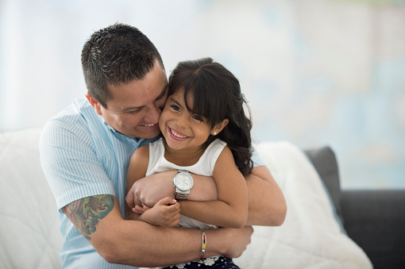
For many families, these important adoption anniversaries are cause for celebration. If you are looking for simple ways to celebrate the completion of your family through adoption, here are five ideas for honoring your child’s adoption date:
- Retell the story. Your child’s adoption anniversary is a great time to open up a conversation about adoption. Look at pictures and review your child’s lifebook, if you have one. You may even work together on a new page to add to their book or to a family scrapbook, documenting your past year as a family.
- Start a tradition. Take an annual family photo, light a candle honoring your child’s birth family, read a favorite adoption book, or start some other meaningful family tradition to recognize this special day.
- Make a favorite meal. Celebrate with your child’s favorite foods or a nice dinner out at his or her favorite restaurant. If you completed a transracial or international adoption, consider making a traditional dish to honor your child’s cultural heritage.
- Host a celebration. Invite other friends and family members over for an adoption celebration. You could also invite other local adoptive families or parents who are interested in adoption or foster care and take it as an opportunity to spread adoption awareness.
- Acknowledge loss. While your child’s adoption day is certainly a happy event for your family and something you want to celebrate, remember that your child may have mixed emotions, especially as he or she gets older. In many ways, adoption is bittersweet, and you should take time on this special day to remember your child’s birth family or birth culture and reflect on their life pre-adoption. Always be respectful of your child’s feelings and their wishes as you decide whether and how you would like to celebrate.
While adoption is a special and life-changing way of adding to your family, adoption day celebrations are not for everyone. Some families feel that a celebration would be insensitive because of the loss inherent in adoption, or that it would make their child feel different from his or her peers. As always, it is important to carefully consider your family’s personal circumstances and your child’s feelings as you talk about and celebrate adoption.
Even if you choose not to recognize your child’s adoption on a specific date every year, remember to take time to remind your child that he or she is loved, cherished, and an important piece that completes your family.

